Regional Seminar on Dangerous Goods Management :
A Planning and Operation Perspective
4 December 2015 (Friday)
The management of dangerous goods and chemicals is a significant challenge to cities and companies. Improper planning, operation or execution of established standards, rules or regulations may lead to catastrophic incidents damaging the environment, and causing harms to the health and safety of the workforce and nearby communities. In this half day seminar, we will review the various risk management approaches and practices in Hong Kong, China and major corporations in high risk industries. By sharing the different approaches, the attempt is to seek a wider learning among professionals and managers in government, companies and industries. Registration is on a first-come-first-served basis. Registration is free of charge for members of the City University of Hong Kong (CityU), South China Environmental and Safety Management Association (SCESMA) and Hong Kong Institution of Environmental Impact Assessment (HKIEIA). Please send your registration to bhricche@cityu.edu.hk before November 20, 2015.

Date | December 4, 2015 (Friday)
Venue | P4701, Academic Building 1, City University of Hong Kong,  Kowloon Tong, Kowloon, Hong Kong
Language | English, Putonghua or Cantonese
Rundown
13:00 - 13:15 | Registration
13:15 - 13:30 | Introduction
13:30 - 14:15 | Risk Management of Major Hazards in Hong Kong, Eddie LEE, Acting Senior Environmental Protection Officer, Environmental Protection Department, HKSAR Government
14:15 – 15:00 | Emergency Preparedness and Response (Exact title to be confirmed), WONG Ka-wing, Leader of HazMat Incidents Training, Divisional Officer, Fire Services Department, HKSAR Government
15:00 – 15:45 | Bulk Chemical Storage in China and Practices: Perspective from a Chemical Terminal Operator, Jobert XIE, Sustainability and Operation Director, TopSafe
15:45 -16:00 | Break
16:00 -16:45 | Conducting Quantitative Risk Assessment of Dangerous Goods Godown in Hong Kong - A Consultant's Experience, Benita KUNG, Associate, AECOM
16:45 -17:30 | Risk Management Process on Dangerous Goods: Perspective from the Petrochemicals Industry, DONG Jiyang, BP
17:30 | Adjourn

Registration Form
Name of Participant
Position
Organisation
Membership | CITYU / SCESMA / HKIEIA
Email Address
Telephone Number
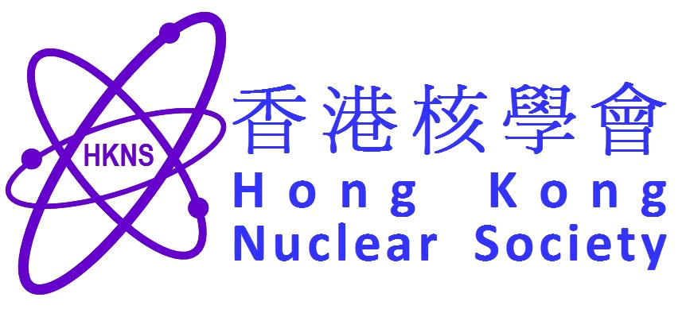
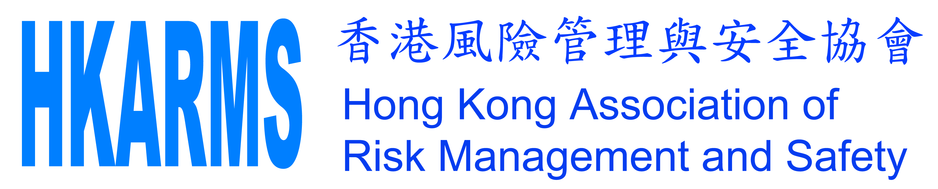
Supporting Organisations:

