How to use “Online booking System”
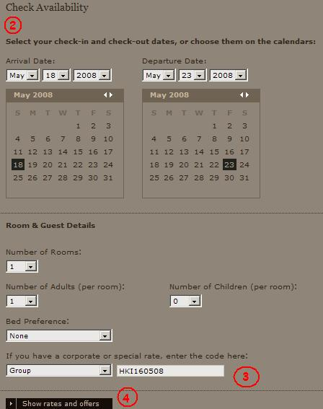

1) Go to the Shangri-La website.
http://www.shangri-la.com/reservations/booking/en/index.aspx?hid=KSL&group_code=HKI160508

2) Select the appropriate hotel and enter all the necessary stay requirements like check-in date, check-out date, number of rooms, adults and children.

3) Under the "Special Rate" area, select "Group Code" and enter the Group Code.

4) Click the show rates and offers to continue.

5) If all the search criteria are correct and rooms are still available for the group, the group rate will be returned in the availability search result. Simply follow the on-screen instructions to complete the online booking.

