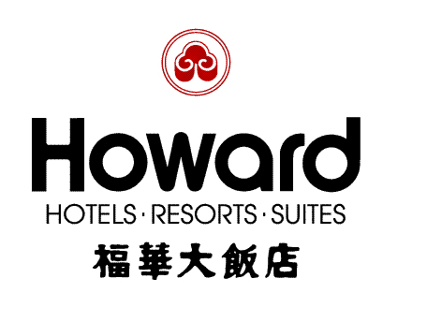
PSAM9
Ninth International Probabilistic Safety Assessment and management Conference
Pre-Conference Work Shop
14TH MAY – 17TH MAY 2008
Hotel Reservation Form
Howard Hotels．Resorts．Suites offers special rates to participants of the PSAM 9 to be held from May 14- May. 17, 2008. To make your reservations, please complete the accompanying form with the appropriate information and return one copy by fax to 886-2-2708-2376 before April. 15, 2008.
Attn： Robert Chen/ Marketing & Sales Dept Tel：+886-2-2326-7527 Fax：+886-2-2708-2376
Robert_chen-tp@howard-hotels.com.tw

The Howard Plaza Hotel Taipei (160 Jen-Ai Road, Sec.3, Taipei)
Room Type | Superior Single Room
Special Rate | NT$3,900+10%/room/night  (Including one daily breakfast)
Note 1:The above rates are valid from May. 14- May. 17, 2008.
Note 2: The above rates are inclusive of complimentary benefits as follows:
*Fruit Basket *Daily Newspaper *One Welcome Drink / per person /per stay
*Free use of Health Club & Sauna
---------------------------------------------------------------------------------------------------------------------------------
Reservation information: (Please type or print clearly)
Guest Name :
Association/Organization: Title: _______________________________
Address : _________________________________
City：_________________Zip Code：________________ Country：____________________________
Tel：__________________Fax：____________________ E-mail：_____________________________
Number of rooms required: Superior King ________ Superior Twin _________

Arrival Date: Flight Details: Departure Date:
Credit Card: □ Master Card □ Visa □ JCB □ AE □ Diners
Card No：□□□□ - □□□□ - □□□□ - □□□□ Expiry Date： （M） （Y）
Card Holder Signature:________________________________ Date：
Transportation Arrangement (Airport Pick Up) :
Limousine (NT$1,680 / car / trip )
Number of persons

* Note1:The foreign exchange rate will be calculated according to the payment-date-rate.
* Note 2: Reservations and room allocation for any of the requested room types will be done on “First come, First serve” base along with the first night deposit. Please kindly provide your credit card details to guarantee your reservations. Any no-show or cancellation of reservations within 72 hours of the arrival date, one night deposit will not be refunded.

