How to use the online final paper submission system

Submitting a final paper
The goal of the PSAM 9 conference is to gather experts from across the technical disciplines that practice the use of probabilistic methods in the design, development, operation, and assurance of today’s modern and highly sophisticated technical systems in order to promote the science and use these methods.
PSAM 9 final papers are due by 8 Feb 2008 Extended to 22 Feb 2008. Final paper must fit in the template provided in the final paper template and be written in English. Please download the final paper template from the below link:
http://iapsam.conference-services.net/solo/viewdocument.asp?conferenceID=1028&filename=documents\template.doc

- Important Information

You can find the final paper template after logging into the “Final Paper Submission” page. - This is a Microsoft Word file which is designed to ensure that your final paper is prepared in the right way for publication. Please save this template file to your PC’s hard drive and use it when you prepare your final paper.

If you are submitting more than one final paper you can use the same email address and password for each paper.
- Final papers are required for all submissions. Final paper MUST be submitted using the template form provided.
- Submitted files are automatically named YOURCONF_001_paper.doc and will not overwrite existing abstracts. If you want to amend your submitted paper, you have to re-submit your paper to overwrite the previous submitted paper.
- Preparation of Your Abstract
- Open the template file and enter your paper title into it following the instructions above. Save it and make a note of its saved location.
- Note: If you are using Word 97 to prepare your abstract and wish to include a table you must insert a text box and then insert the table within the text box. It is not possible to use the insert table function in Word 97 in the abstract template without doing this.
- The Submission Process
- Log in to the submission system when your paper is completed and ready to send. To log in, enter your email address and the password you chose when you registered with the system.
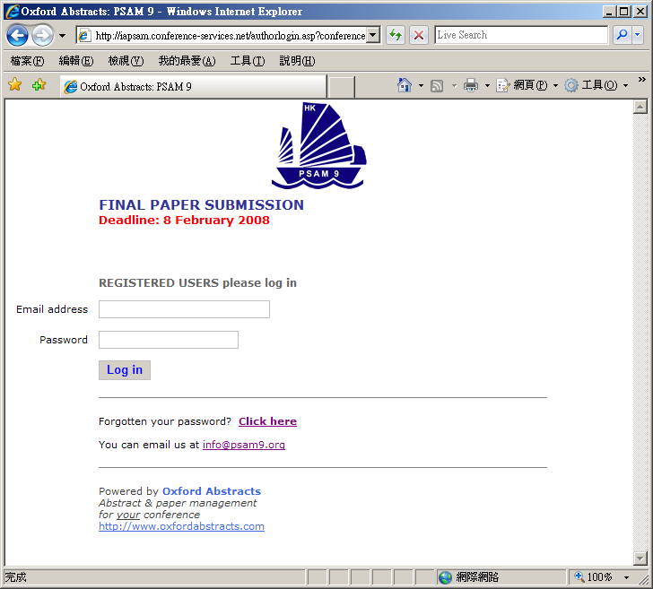
- When you click the “log in” button you will be taken to a screen from which the submission process starts. Please read the instructions on this screen carefully.
- You will see a list of the abstracts that you have submitted. Click on the title that you wish to submit corresponding paper.
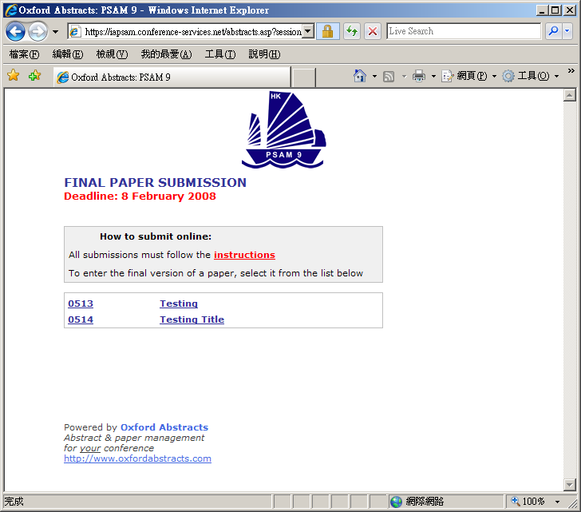
- Submitting a paper is a multi-step process. Each step asks several questions:
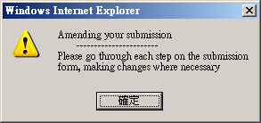
- During the submission process you will be asked to click the “Browse” button and locate your paper file on your PC’s hard disk. No specific filename format has to be followed as the filename will be renamed automatically by our system. Fill in and review the answers to any other questions on this screen and then click the “Next” button. Your paper file will be sent to our system – this can take a few seconds if you have a fast internet connection, but may take longer if your connection is slow or you have included lots of graphics in your paper. Please be patient!
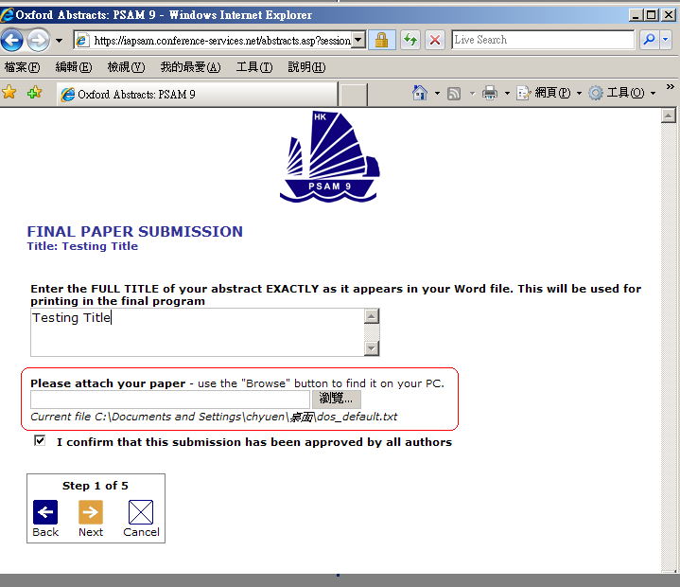
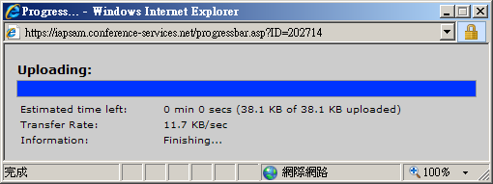
- You can copy the paper title from your Word document and paste it into the Title field on the submission form. Please note that because of web browser limitations some scientific symbols may not paste correctly into the form – you may have to correct this by writing the name of the symbol in full, for example “beta” instead of β. Your Word document will not be affected.
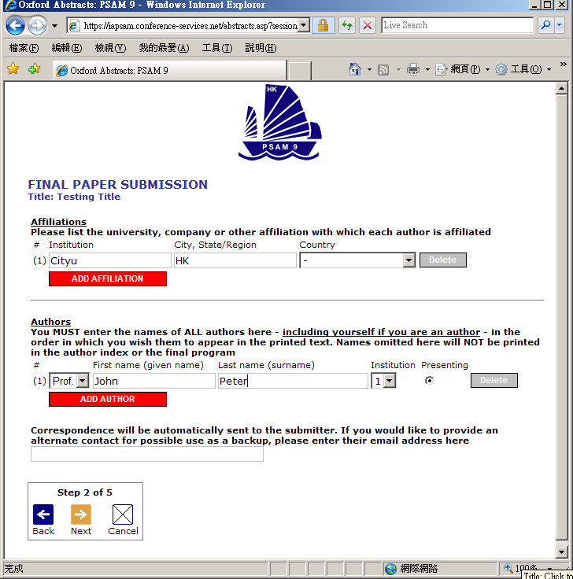
- You will find the questions are automatically filled in with the answers that you gave previously (in the abstract submission stage) – you don’t have to change an answer if you don’t want to.
- Some questions are marked (required). We cannot accept your paper until these questions have been answered.
- If you do not know the answer to a question – for example you may not be sure in which category your abstract should be presented – you can skip the question and return on a later occasion to complete it.
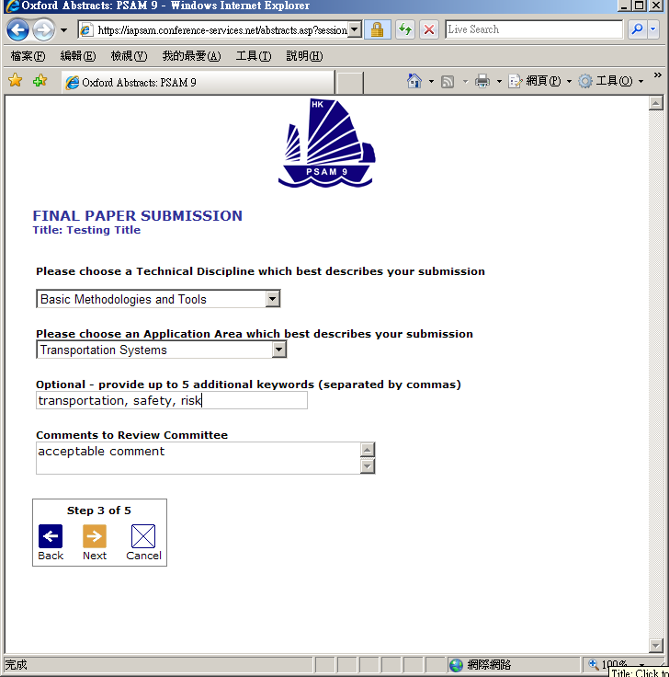

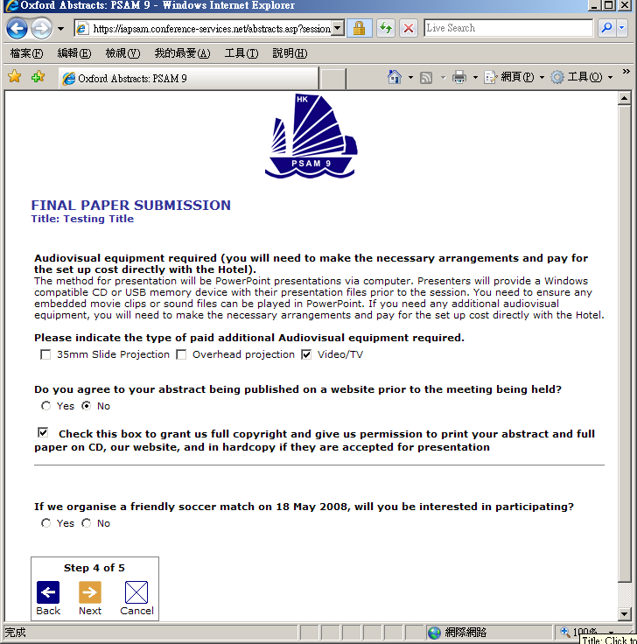
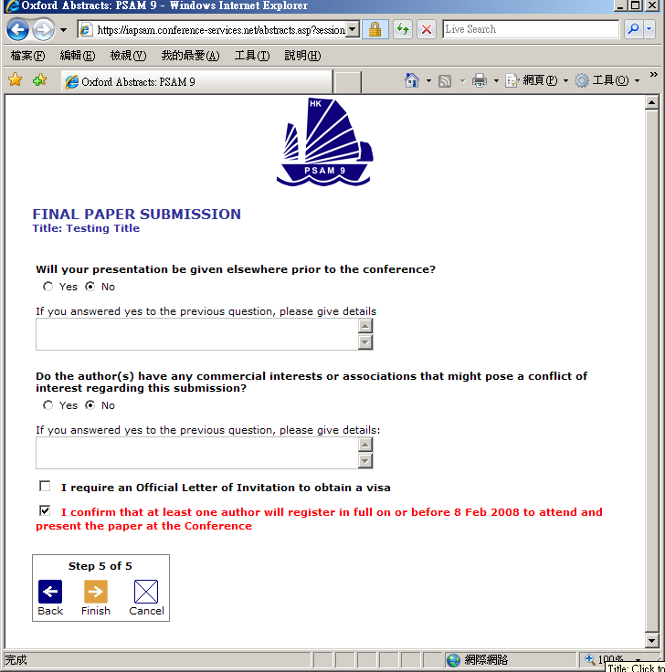
- Once you have completed the final step click the “Finish” button. A confirmation email will be sent to you. If you have answered all the required questions, you will receive email confirmation. If you have not answered all the required questions your paper will be held in temporary storage until you return later and complete all the questions.
- 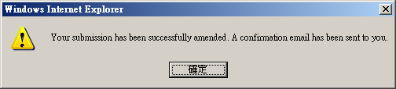

Amending a submission
You may wish to change your answers to some of the questions on the submission form, or even to change the abstract file itself.
- Log in to the submission system
- You will see a list of the abstracts that you have submitted. Click on the abstract that you wish to submit the corresponding paper.
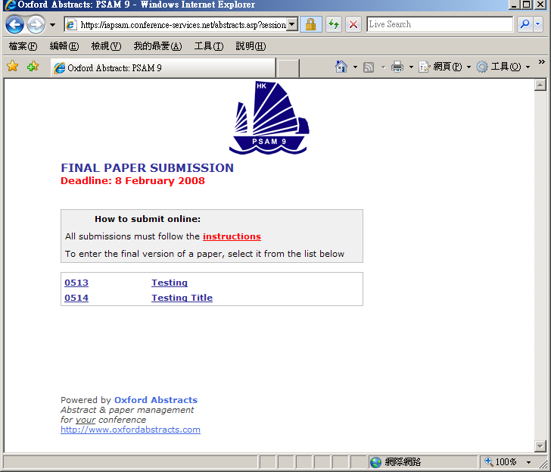
- The process of amending a paper is the same as the original submission process, except that the submission form will be automatically filled in with the answers that you gave previously – you don’t have to change an answer if you don’t want to.
- If you want to change your paper file you can click the “Browse” button to locate the revised file on your PC’s hard disk, then click “Next” to send it to the abstract system. If you don’t want to change the file, just press “Next” to bypass this step. Even resubmit the paper, no specific format is required for the paper as our system will automatically rename the newly submitted paper.
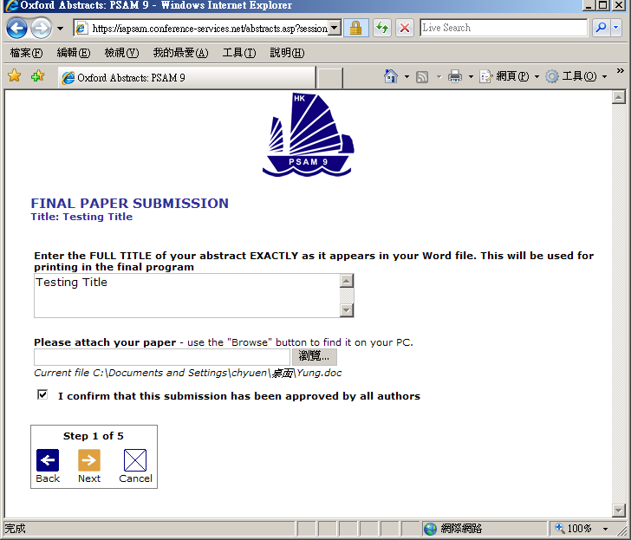
- When you reach the final step and press “Finish” you will be sent an email confirming that your paper has been amended – provided you have answered all the mandatory questions.

Withdrawing an abstract
If you want to withdraw a paper please contact the Conference Administrator at info@psam9.org

